**Maritime Perspectives – Our Performers today**

**Scaplen’s Court Players**

Scaplen’s Court Players began in 2019 when Carole Allen, Producer and Jo Puttick decided to bring to life the first of three short historic plays deriving from the Rotary Club of Poole Bay’s Pirates Castaways & Codfish project. Carole cast the first play *Mayhem at the Inn* and in June 2019 it was performed in the downstairs kitchen of C14th Scaplen’s Court Museum; true theatre in the round, with the audience closely interspersed with the players.

The project delved into the maritime heritage of Poole between 1580 and 1730 and the play featured an event that might have happened in Poole during 1623 when the press gang came to town looking for seamen to press for the Navy. The production was evidently so well enjoyed by those present that a second play was written and performed in 2021 concerning a Poole woman and her husband, Elizabeth and Thomas Hyde, reputedly helped Mary of Orange to pass messages to her husband William in late 1688, then marching his troop across north Dorset, to take the Crown of England.

The Players grew to include storytellers too across the period, who in period dress tell short tales of life in old Poole and the trip to Newfoundland for fishing.

**The Storytellers - Tales of Old Poole in C17th**

Casting Director - **Carole Allen**

Director of storytelling - **Andrew Whyatt**

Robert - **Don Gent**

Jane - **Nicola King**

**The Shanty Singers**

**Choir Engine**

Choir Engine, founded by Caroline Moss is a fun, friendly, local and talented Community Choir. They have an extensive repertoire and perform together across Dorset. A mix of children, parents and grandparents, united through their love of singing, they hope you enjoy listening as much as they enjoy performing.

**Save the Whalers**

John Wilkes has been involved with the Scaplen’s Court Players since their inception. He has led the singing of sea shanties in the plays and is engaging more with the audience this year. Save the Whalers provide a chance for you all to join in with their sea shanties, so much a part of life in early Poole.

**Poole Rotary Club acknowledges our many supporters in the project and the help received today from many local volunteers and organisations:**

* **Our many Rotary volunteers, involved in the project and our hosted events**
* **The volunteers from the public who helped our research, earlier project activities and today’s shanty singing**
* **The contributors to our cinema events, and Scaplen’s Court Players both cast and production team for today’s events**
* **The many contributions to our drama today, in particular those from: Brownsea Open Air Theatre; Bournemouth Little Theatre; Pirates of Poole; Poole Men’s Shed**

**Maritime Perspectives (Sherling Studio)**

**Today’s Shows in the** Sherling Studio derive from the project undertaken by Poole Bay Rotary, **Pirates Castaways & Codfish**, highlighting Poole’s maritime heritage 1580-1730.

**Earlier this year Poole Bay Rotary merged with Poole Rotary Club** which is delighted to present for you the following performances. These have only been made possible with the considerable help of our volunteer performers and their supporters here today.

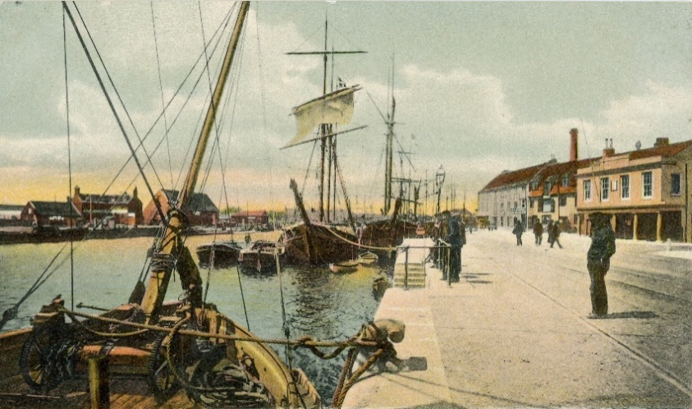

**Shanty Singing**

**Choir Engine**  **–** Choir Master, **Caroline Moss**

**Save the Whalers** – Scaplen’s Court Players

**Storytelling** – **Performed by Scaplen’s Court Players**

**Robert’s story**

**Jane’s Story**

**Drama**

**Woodes Rogers and the End of the Golden Age of Piracy -(1718-1721)**

Written by **Don and Katy Nutt**

**Performed by Scaplen’s Court Players**

**Woodes Rogers and the End of the Golden Age of Piracy**

**(1718-1721)**

By **Don and Katy Nutt**

**Cast (**in order of appearance**)**

Shanty Singing **- John Wicks & Claire Atkinson**

**Scene 1 – The Quay, Poole**

Captain Peter Joliffe (& Narrator) – **Lindsay Jones**

Woodes Rogers - **Nathanial Bradley**

Robert Williams - **Jack Davenport**

**Scene 2 – New Providence, Bahama Islands**

Suzy (barmaid) - **Dionne Polychronopulos**

Edward England. - **Dave Clements**

(Calico) Jack Rackham - **Barry Gray**

Edward Thatch (Blackbeard) - **Chaz Davenport**

Charles Vane - **Bob Rankin**

Jacques (John) Martin - **Laurent Lucas**

Edward England - **Dave Clements**

Mark Read - **Rachael de Courcy Beamish**

An...drew Bonny - **Marie Bushell**

Priest (Drunken Sailor) - **David Vinter**

**Scene 3 – Port Royal Gaol, Jamaica**

Dippy Wilkes (Turnkey) - **Phil McMullen**

Anne Bonny - **Marie Bushell**

Mary Read - **Rachael de Courcy Beamish**

**Production Team**

Producer and Casting Director - **Carole Allen**

Director of Play and voice coach - **Jo Puttick**

Fight Director - **Brian March**

Costumes - **Christine Orridge**

Stage Manager - **Glanville Noye**

**The story of today’s play –** Don Nutt

Little did we think when we began this project that it would lead us to bring such well known pirate characters to Poole, including Blackbeard, Jack Rackham, Charles Vane, Anne Bonny and Mary Read!

Woodes Rogers, a boy on Poole quay in the 1680’s, came to our attention for his subsequent extraordinary maritime exploits. The story of his life and an extraordinary link to Blackbeard that emerged during our project, led us to write this play. What’s more we believe that the story is quite probably true…..!

The three scenes of the play illustrate Woodes Rogers’ extraordinary life. It is focussed on one aspect of his career, scarcely heard of in Poole today but which highlights the extraordinary times.

The play, its locations, key characters and dates is historically accurate. Captain Peter Joliffe, introduced in the first scene, becomes narrator for the remainder of the play:

* **Scene 1: On Poole Quay – 1693** Woodes and Robert are fishing for breakfast on Poole Qua. Woodes Rogers is 14 years old and his friend Robert Williams is a little older. They both live nearby. Captain Peter Joliffe comes along and starts a conversation. Peter runs a merchant shipping business from Poole and he is interested to hear what the boys plan to do with their lives.
* **Scene 2: New Providence bar (Nassau), Bahamas -May 1718**; Edward Thatch (Blackbeard), (Calico) Jack Rackham and Charles Vane, the famous pirates, and others, are deep in discussion. It is happening because of Woodes Rogers’ arrival on the island in a few weeks’ time, to establish a first British Colony. Rogers has the King’s backing and a fleet of seven vessels plus some Royal Navy support. He also has over 150 men, in his own pay, to rebuild the old wooden fort, in stone and to defend it.

Two laughing pirates enter the bar interrupting the conversation. The two women pirates, dressed as men,are Anne Bonny and Mary Read. They frequently sail with Rackham locally – ‘a piratin’. They all know of the King’s pardon for them provided they change their way of life, but they support the ‘pirates’ republic’ there; declared by Captain Benjamin Hornigold a year earlier.

Blackbeard, is now the top pirate of the Caribbean, with seven vessels and 700 crewmen. Hearrived yesterday for just a few days. Charles Vane, most senior pirate on the Island; also, just arrived back from a successful pirate voyage, with French ‘prizes’ and 70 more men. Blackbeard wants to know whether they think the King’s pardon will change things. He’s read a book about Woodes Rogers and has a high opinion of his abilities. He thinks Rogers will succeed in his ambitions for the Bahamas; bad news for the pirates and piracy thereabouts.

* **Scene 3: Port Royal gaol, Jamaica, on 19thNovember 1720** (the day of Jack Rackham’s death by hanging.)After two years of piracy, off and on, JackRackham, Anne Bonny, Mary Read and crew left New Providence in early 1720, stealing the sloop, William. They went pirating despite already taking the King’s pardon. Both Anne and Mary were actively involved in the theft. In October, Woodes Rogers’ alerted Boston Gazette readers to the pirates’ existence and the William’s theft. Captain Barnet, a British navy pirate hunter, then caught and arrested them. In the altercation, the crew below decks were too drunk to respond; but both Anne and Mary were involved in hand-to-hand deck fighting, adding to their notoriety. Jack was tried, found guilty, sentenced on 18th, and hanged on 19th November 1720. Anne Bonny and Mary Read were tried together, ten days later, also found guilty and sentenced to be hanged. They ‘pled their bellies’ and were found to be pregnant, and their death sentences were commuted but they stayed in gaol.

Charles Vane is thought to have been in the same gaol then, having been captured nearby by an English merchant captain. He was also tried, found guilty and sentenced to death on 28th March 1721 and hanged the following day. Like Jack’s before him his corpse in a gibbet was displayed prominently in the harbour; the decaying bodies within sight of one another. Mary Read died in March 1721, in the prison during childbirth with a high fever. Anne Bonny is said to have been rescued from further imprisonment by her father who perhaps ‘bought her out of prison’ and took her back to a life in Charleston, South Carolina. There she is thought to have had eight children and lived to the ripe old age of 84.

The end of these pirates’ lives marked the end of the golden age of piracy in the Caribbean; Woodes Rogers’ was instrumental to bringing it to a close. International commerce and trade flourished as a result.