 | Scaplen’s Community Players  Membership Policy | 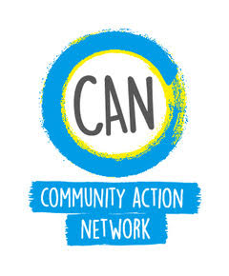

We are a voluntary, democratic, not- for- profit, community organisation. Our structure is one of membership run by a committee.
If you want to be involved in one of our plays or take part in any of our activities, you must be a member of the group for insurance purposes. Membership is open to anyone who
- Supports the aims of our group
- Lives in the Bournemouth, Christchurch, Poole and the Dorset area
All members will be required to pay a membership fee of £25.00 This amount will be agreed every year at the group’s Annual General Meeting. Membership will run for one year and subscriptions should be paid on or soon after January 1st as possible. A list of members will be kept by the secretary.
Our preferred method of payment is by bank transfer. Please find details of how to do this on our Membership page.
All members will receive regular Newsletters. These will include information about our next production, auditions, workshops and social events. Members will also be able to buy discounted tickets for Scaplen’s Community Players performances.
We regret that we are unable to accept child membership except where a parent is a member too and where they take full responsibility for chaperoning their child. A child legally needs to have a chaperone up to age 16 or until they have completed their compulsory education. (Child Protection Policy)
Any offensive behaviour including racist, sexist or inflammatory remarks will not be permitted. Anyone behaving in an offensive way or breaking our (Equality, Diversity and Inclusion Policy) may be asked not to attend further meetings. Persistent offences may result in membership being withdrawn.

scaplens.communityplayers@outlook.com

